

Logbook

BIT4133: Natural Language Processing with Deep Learning
STUDENT DETAILS
NAME : ABDULMALIK HAMED
ADM NO. : BSCCS/2024/33590

COURSE/CLASS : COMPUTER SCIENCE JAN 24

Unit Code: BIT4133

Unit Name: Natural Language Processing with Deep Learning

Lecturer Name : MICHAEL NYORO

Semester/Academic Year : YEAR 4 SEM 2

Project : Text Classification

Technologies Used

Python, NLTK, Scikit-learn, Google Colab, Jupyter Notebook

GitHub Link
https://github.com/saidabdulmalik735-source

Table of Contents
Logbook 1
BIT4133: Natural Language Processing with Deep Learning 1
Project : Text Classification 1
Technologies Used 1
• Python 1
• NLTK 1
• Scikit-learn 1
• Google Colab 1
• Jupyter Notebook 2
GitHub Link 2
Week 1: Introduction to NLP and Applications 4
Title : Introduction to NLP Concepts and Text Processing 4
Fig 1: Python Installation 4
Fig 2: Jupyter Notebook or Google Colab Setup 4
Fig 3: NLTK Installation 5
Fig 4: Tokenization Output 5
Fig 5: Stopwords Removal Output 6
Fig 6: NLP Application Research Evidence 6
Student Reflection 6
Week 2: N-gram Models and POS Tagging 7
Title : Language Modeling and Sentence Structure Analysis 7
Fig 1: Bigram or Trigram Output 7
Fig 2: POS Tagging Example 8
Fig 3: Python Code for POS Tagging 9
Fig 4: Language Prediction Example 9
Fig 5: Sentence Analysis Output 10
Week 3: Hidden Markov Models and Sequence Labeling 10
Title : Sequence Prediction and Hidden State Analysis 10
Fig 1: Sequence Labeling Code 10
Fig 2: Hidden Markov Model Output 11
Fig 3: Named Entity Recognition Example 11
Fig 4: Sentence Labeling Results 12
Fig 5: Dataset Used for Training or Testing 12
Week 4 : Sequence Prediction and Hidden State Analysis 13
Fig 1. Install spaCy and Language Models 13
Fig 2. Dependency Structure Analysis 13
Fig 3. Semantic Similarity Comparison 14
Week 5 Mini Project: Student Academic Assistant Chatbot 15
Fig1. Python Source Code 15
Fig 2. Chatbot Interaction Output 15

Week 1: Introduction to NLP and Applications

Title : Introduction to NLP Concepts and Text Processing

Fig 1: Python Installation
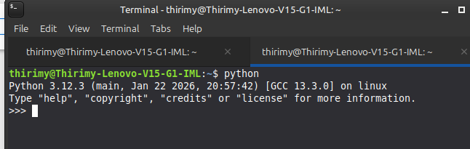

Fig 2: Jupyter Notebook or Google Colab Setup
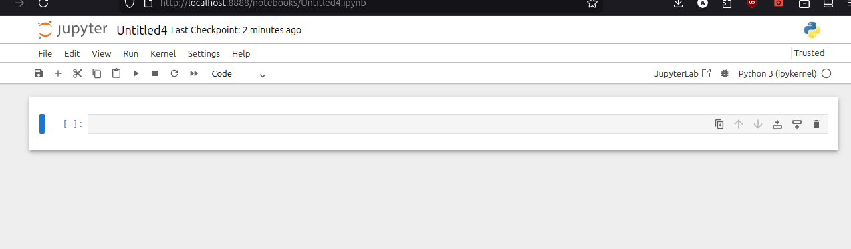

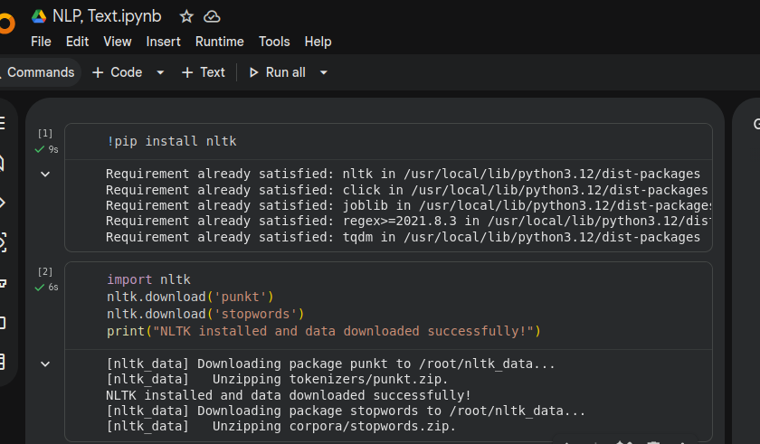
Fig 3: NLTK Installation

Fig 4: Tokenization Output
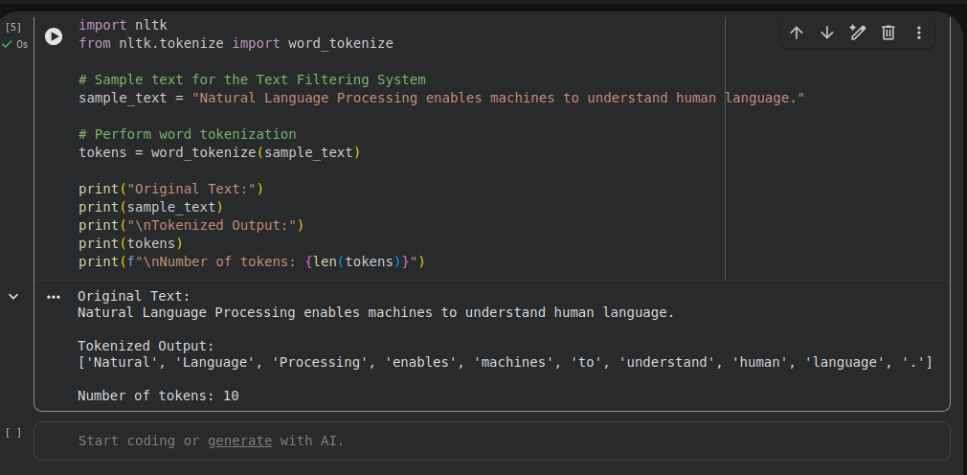

Fig 5: Stopwords Removal Output
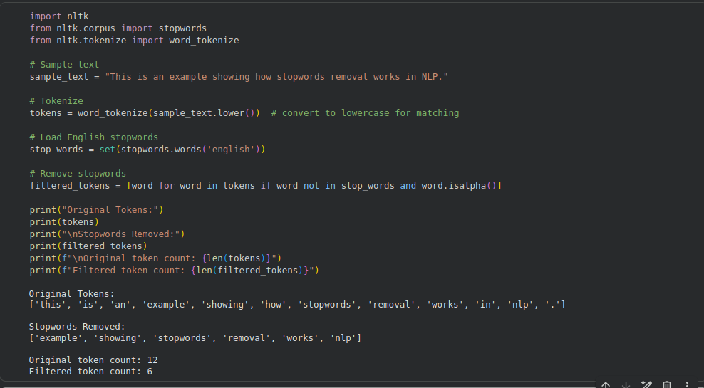

Fig 6: NLP Application Research Evidence

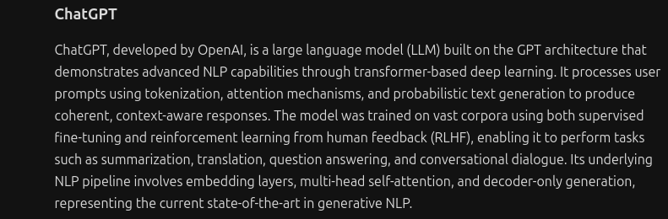

Student Reflection

What was learned
- How to set up a Python NLP development environment (Jupyter/Colab, NLTK)
- Core text preprocessing techniques: tokenization and stopwords removal
NLP applications explored
- ChatGPT, Google Translate, Siri, Alexa, Spam Filtering
Technologies used
- Python, Jupyter Notebook / Google Colab, NLTK library

Week 2: N-gram Models and POS Tagging

Title : Language Modeling and Sentence Structure Analysis

Fig 1: Bigram or Trigram Output
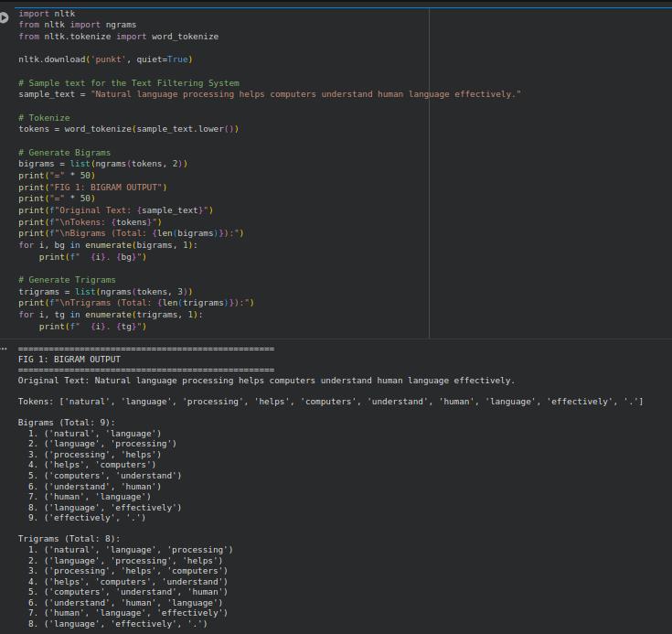

Fig 2: POS Tagging Example
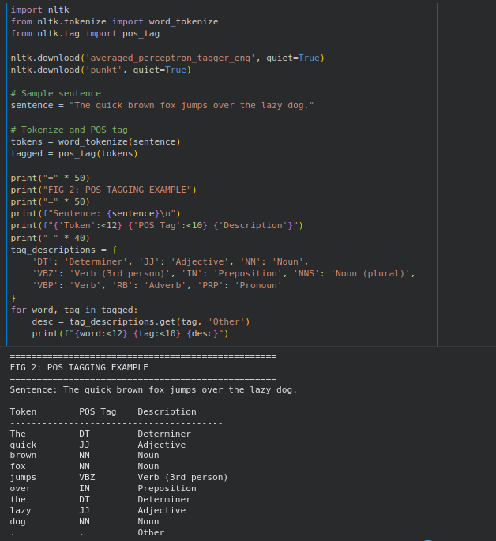

Fig 3: Python Code for POS Tagging
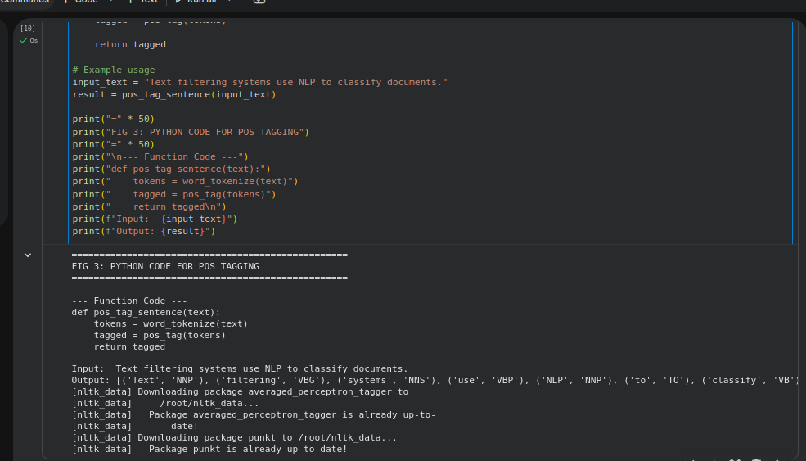

Fig 4: Language Prediction Example
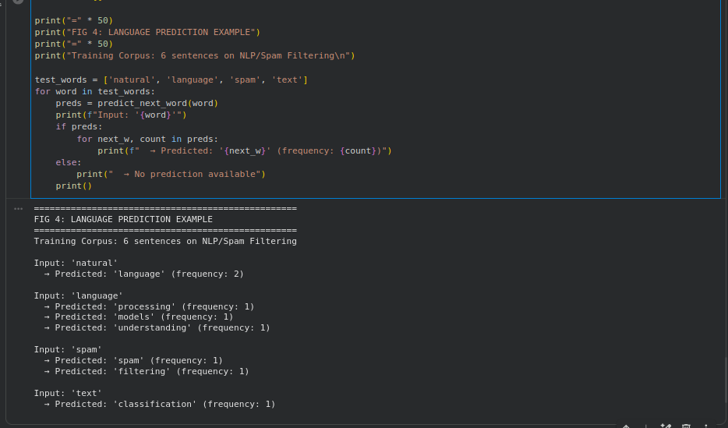

Fig 5: Sentence Analysis Output
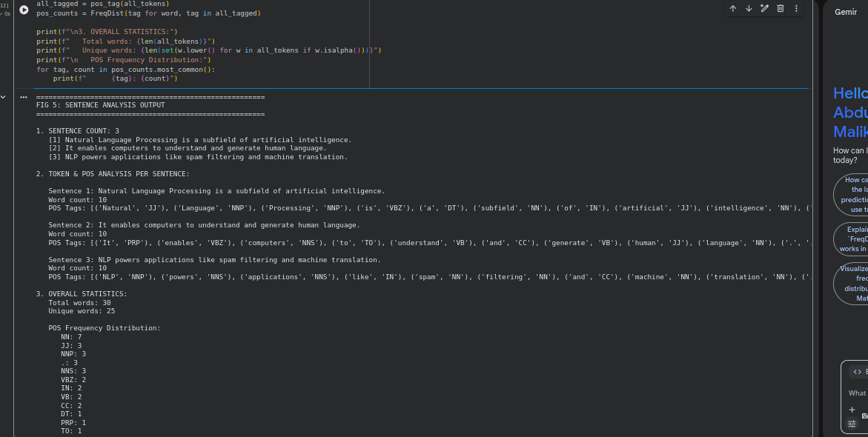

Week 3: Hidden Markov Models and Sequence Labeling

Title : Sequence Prediction and Hidden State Analysis

Fig 1: Sequence Labeling Code
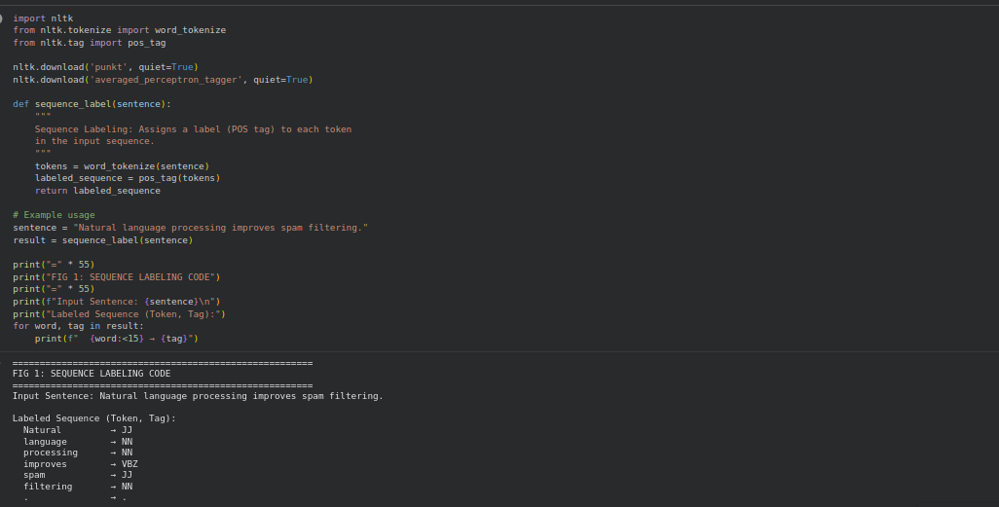

Fig 2: Hidden Markov Model Output
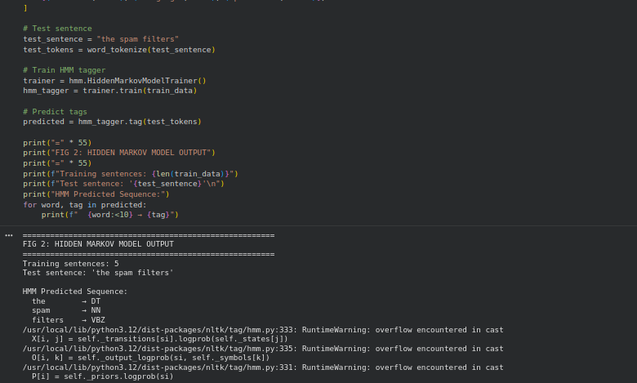

Fig 3: Named Entity Recognition Example
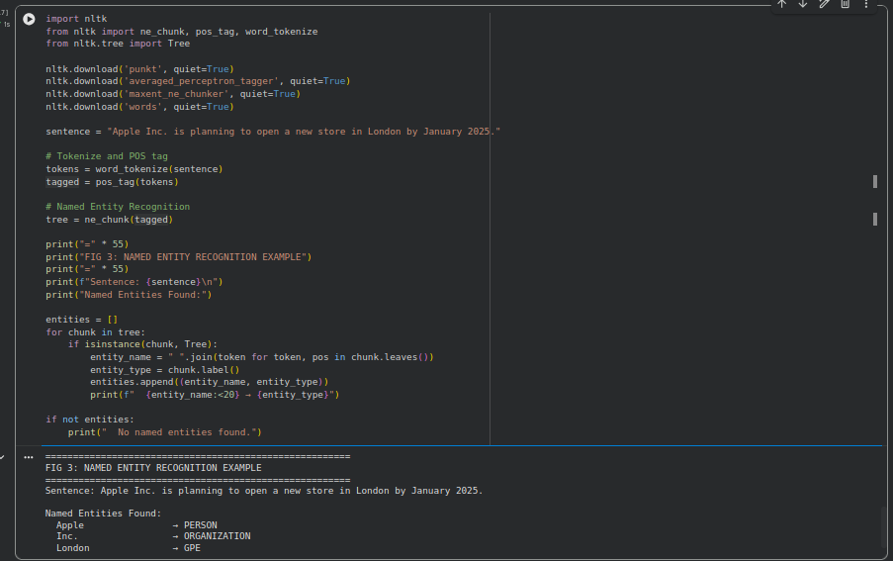

Fig 4: Sentence Labeling Results
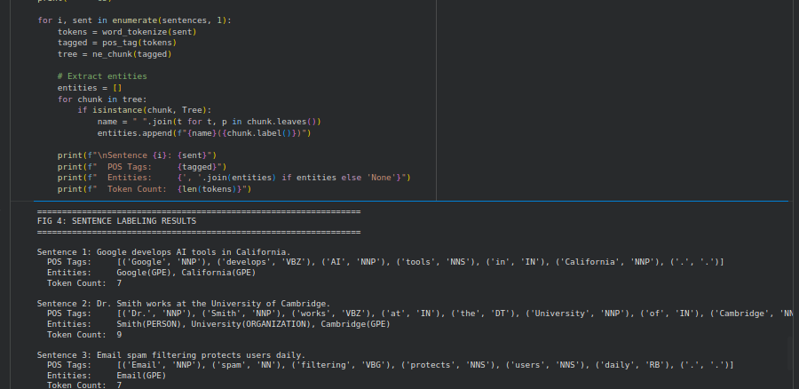

Fig 5: Dataset Used for Training or Testing
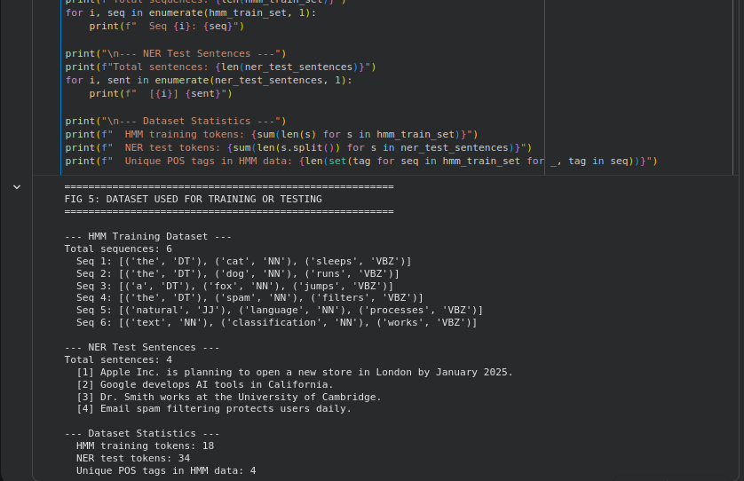

Week 4 : Sequence Prediction and Hidden State Analysis

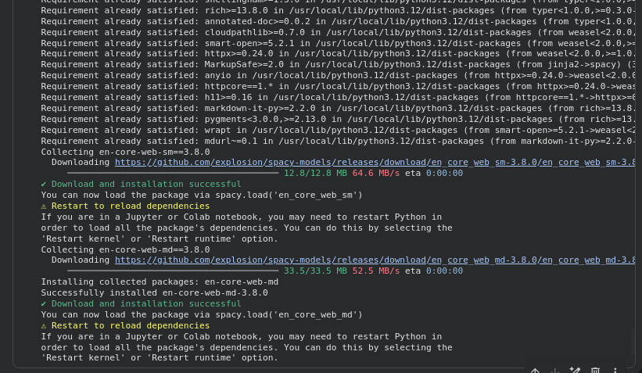
Fig 1. Install spaCy and Language Models

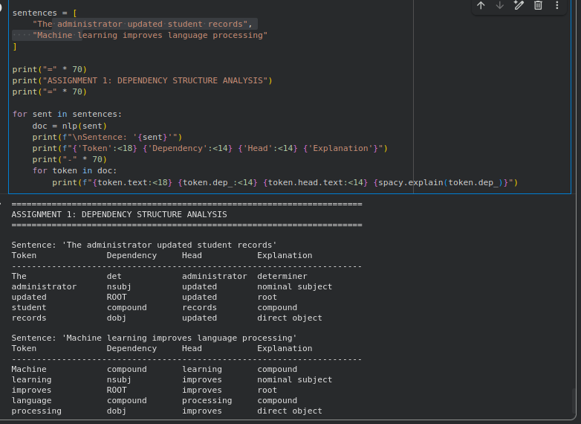
Fig 2. Dependency Structure Analysis

Fig 3. Semantic Similarity Comparison
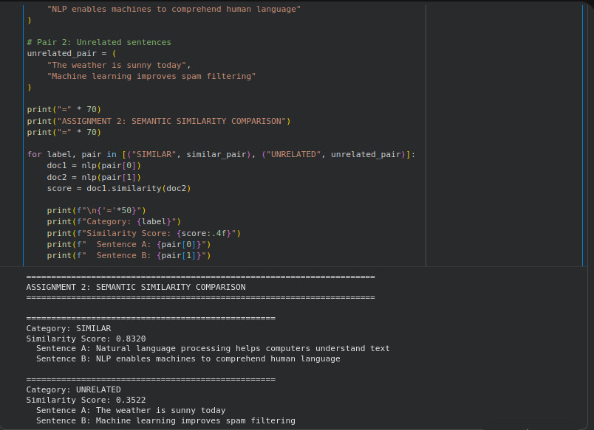

Week 5 Mini Project: Student Academic Assistant Chatbot

Fig1. Python Source Code
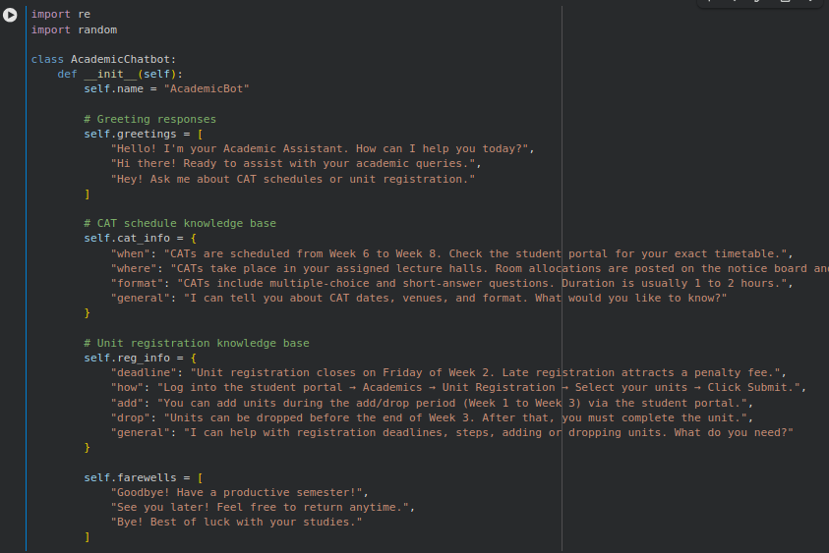

Fig 2. Chatbot Interaction Output
